

**Project Report**

**on**

**School Management System**

Submitted to

**LOVELY PROFESSIONAL UNIVERSITY**

in partial fulfillment of the requirements for the award of degree of

**Bachelor of Computer Science and Engineering**

**Submitted By Submitted to**

**ANSHUL KUMAR SINGH NAVNEET KAUR**

**11814863 Assistant Professor**

**LOVELY FACULTY OF TECHNOLOGY & SCIENCES**

**LOVELY PROFESSIONAL UNIVERSITY**

**PUNJAB**

**April 2021**

**Table of Contents**

**Chapter Particulars Page No.**

1. Introduction……………………………………………………… 3
2. Technology used………………………………………………… 4
3. Modules………………………………………………………..... 4 - 6
4. Screen Shots ……………………………………..……………… 7- 16
5. GitHub link and video presentation link……………………….... 17

References…………………………………………………………………

**CHAPTER 1**

**INTRODUCTION**

**1.1 School management system**

School management system project is a project in which one can manage all the activities of a school. This project is useful for administration of a school college where user can manage school activities like manage students, manage teacher, manage result, manage fee etc.

**1.2 Objective of School management system**

Some main points of my objectives of this management system.

**Computerization** – All the details regarding school, whether it is small or big, will be computerized.  
No Redundant Data – As this management system will be centralized, the chances of the duplicate data in the system are close to nil.

**Automation** – The automation feature of this management system will mitigate the task of writing the papers. Ex- there is no need to write the report card of the students on the paper by the pen. It simply can be done online on the system and can be forwarded to the students and their parents.

**Easy Interaction**– In today’s rush hour of the life, it is difficult for a parent to go to the school of his / her child every time a teacher call.

By this management system, it will easier for a parent and a teacher to be in touch every day. As a matter of fact, it will be easier for each individual person who is associated with the system to be in touch as per needed.

**1.3 Key Features of School management system**

* Multi-User Account System
* Responsive User Interface
* Student Fee Management
* Profile System
* Exam Marks Management
* Analysis of Exams
* Teacher Management
* Student Management
* Daily Attendance
* New Registration

|  |
| --- |
|  |

**CHAPTER 2**

**TECHNOLOGY USED**

**2.1 Language Used**

The frontend of the project is made by using HTML, CSS and Bootstrap.

For the backend we have used PHP, JavaScript and MYSQL.

**2.2 Software Used**

I have used following basics software for the project –

1. Visual Code Studio
2. Web browser (Google Chrome)
3. XAMPP local server

**CHAPTER 3**

**MODULES**

**3.1 About the Project**

In my School Management System project, I have implemented almost all the basic functionality of a school.

I have implemented following modules which are listed below –

**3.2 Home Page**

The home page consists of four buttons namely Home, Contact Us, Locate Us and Sign Up at the top right of the home page. These all buttons are functional. I have included Login form on the home page using which user can access my project.

**3.2.1 Login**

Users have to login to get access to the dashboard to manage all the activities of school/college. User can login to this project by creating their account and logging into it.

**3.2.2 Sign Up**

User needs to create their respective accounts to be able to get access for logging in.

**3.3 Dashboard**

When User successfully logged in to the project, he will be redirected to dashboard page. I have divided dashboard page into some sections like-

**3.3.1 Sub-Dashboard**

**[1] Student record –**

This section shows the brief detail of all the students in the school like total number of the students, total active students and total in-active students. User can also see the complete list of all the student in school.

**[2] Teacher record –**

This section shows the brief detail of all the teachers in the school like total number of the teachers, total active teachers, total in-active teachers. User can also see the complete list of the teacher in school/college.

**[3] News section –**

This section shows some latest news. Here user can show some important news related to school.

**[4] Some important links section –**

In this section admin can show some important links that are related to school or students at the school.

**3.3.2 Buttons on the Dashboard**

**[1] Home-**

This section will redirect to the dashboard.

**[2] Manage students –**

As the name of the module this module manage student’s activities where user can manage all the activities like –

1. Add a student
2. Edit a student
3. Search a student
4. Delete a student
5. Print all students list

**[3] Manage teacher –**

As the name of the module this module manage teacher’s activities where admin can manage all the activities like –

1. Add a teacher
2. Edit a teacher
3. Search a teacher
4. Delete a teacher
5. Print all teachers list

**[4] Manage Result –**

This module implements result related activities like –

1. Add result
2. Search result
3. Edit result
4. Delete result
5. Print all student’s result

**[5] Manage certificate –**

Manage certificate module is used to generate certificate of a student who leave the school. Admin can generate a certificate for a student and provide that certificate to the student. The certificate is auto generated.

**[6] Manage fee -**

This module is used to implement fee related activities like –

1. Pay fee/Update fee status
2. Print the list of the student who have paid the fee.
3. Print the list of the student who have not paid the fee.

**3.4 Database**

To store the data of the project we have create following tables in RDBMS –

**Students table** – This table store all the details of a student.

**Students table column** – id, roll_no, fname, lname, mother_name, father_name, dob, gender, category, mobile, class, address, status, fee_status

**Teachers table** – This table store all the details of a teacher.

**Teachers table column** – id, fname, lname, dob, gender, email, mobile, subject, status, address

**Admin table** – This table store the admin details.

**Admin table column** – id, name, email, password

**Result table** – This table store marks of all the students, used to generate result.

**Register table**- This table stores new admission of students.

**CHAPTER 4**

**SCREENSHOTS**

**[4.1] Home Page/ Login Page**

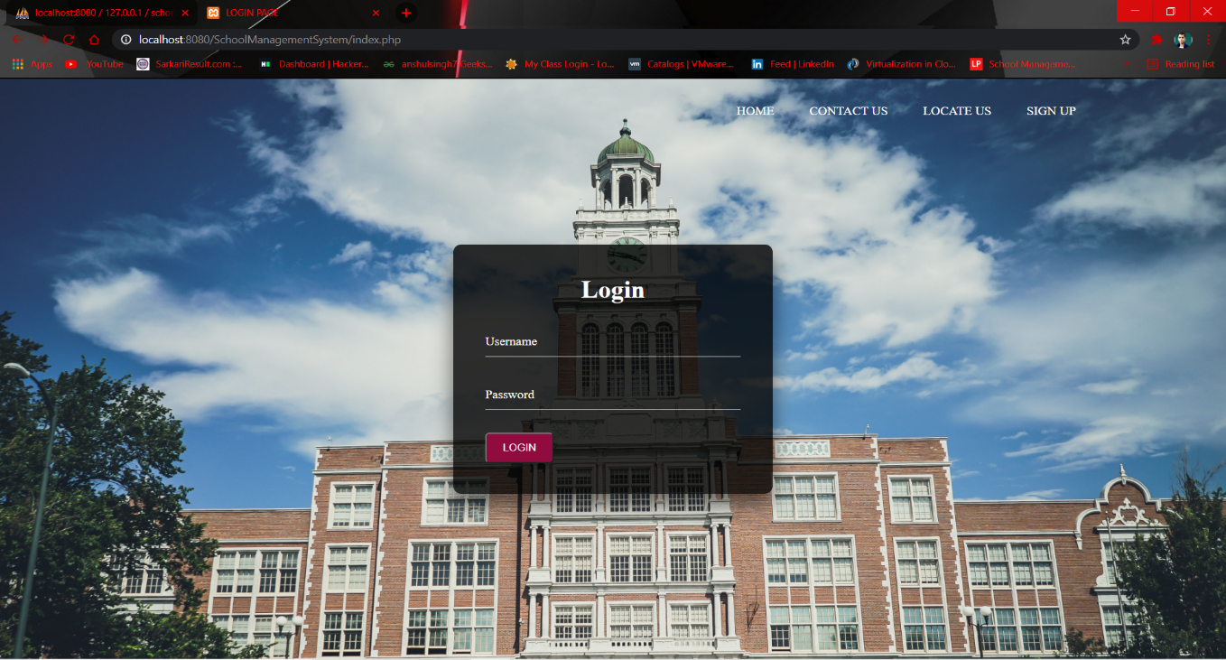

**[4.2] Signup**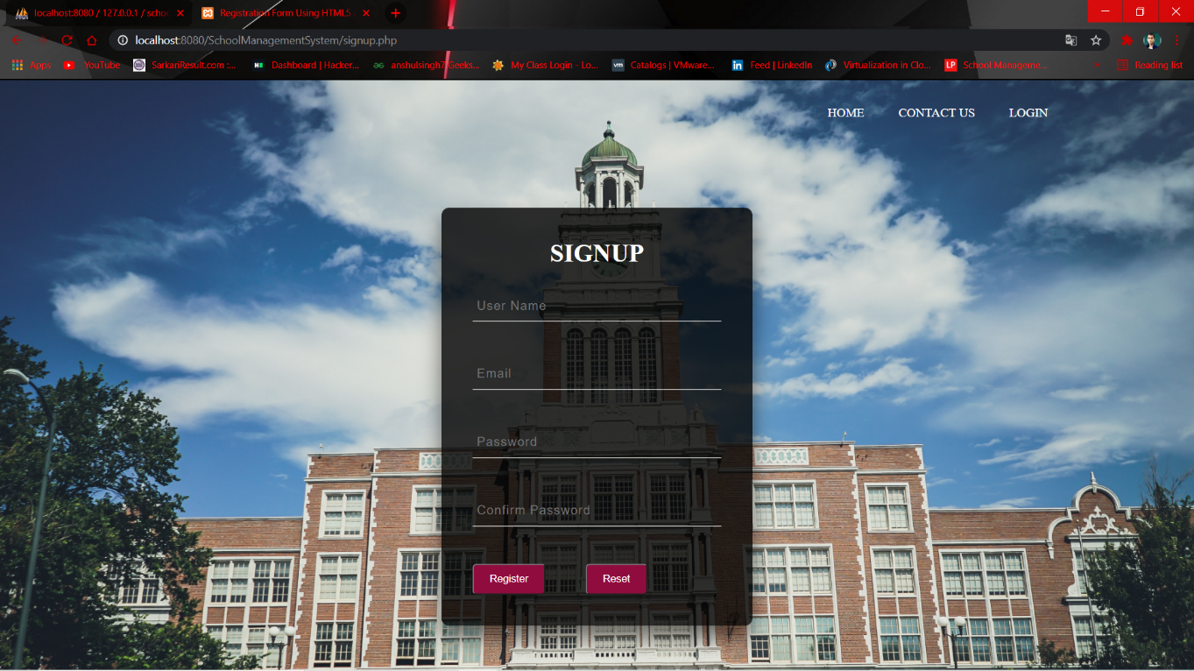

**[4.3] Contact Us**

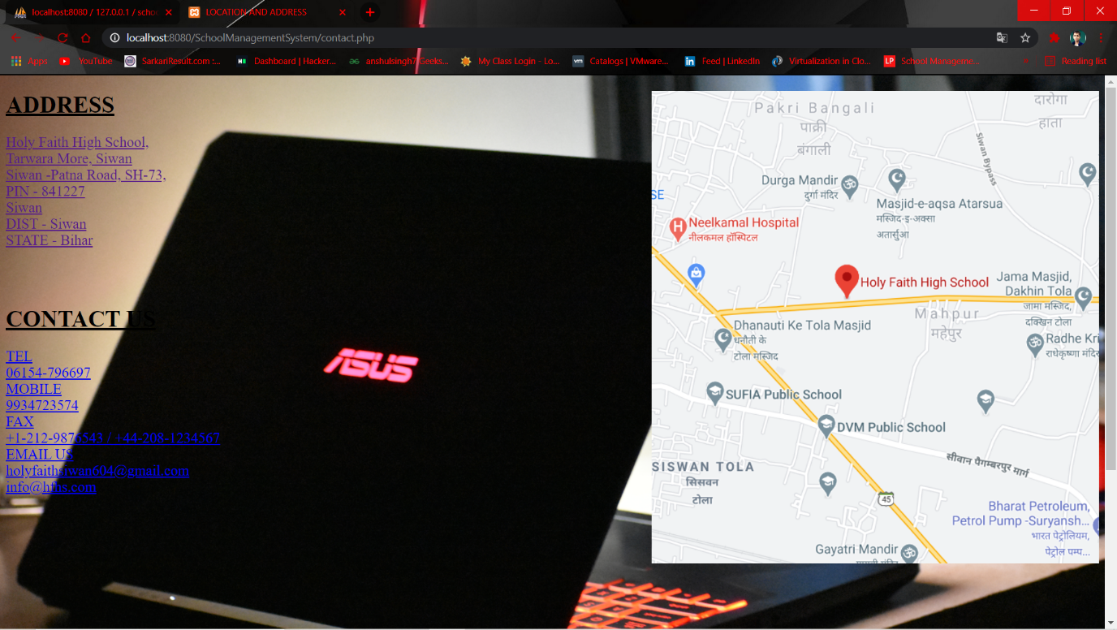

**[4.4] Locate Us**

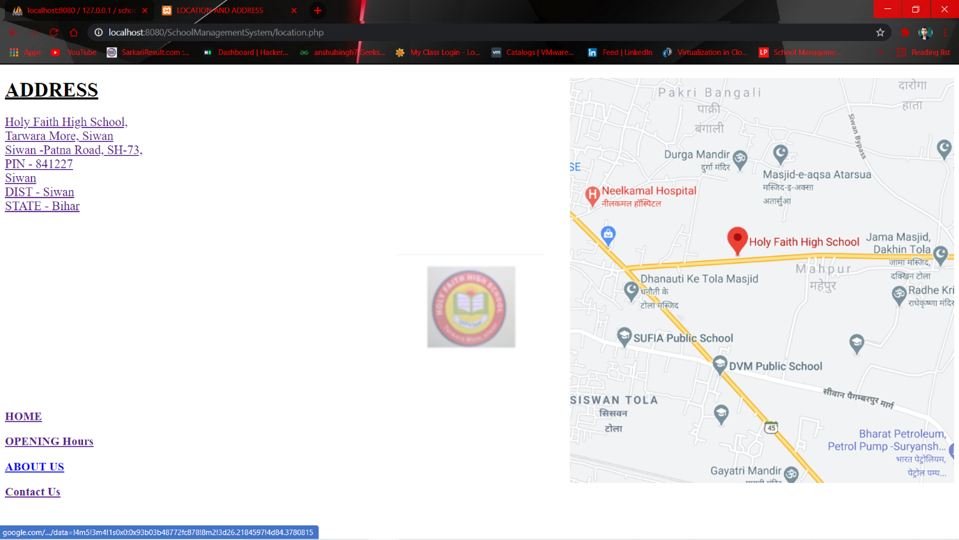

**[4.5] Dashboard**

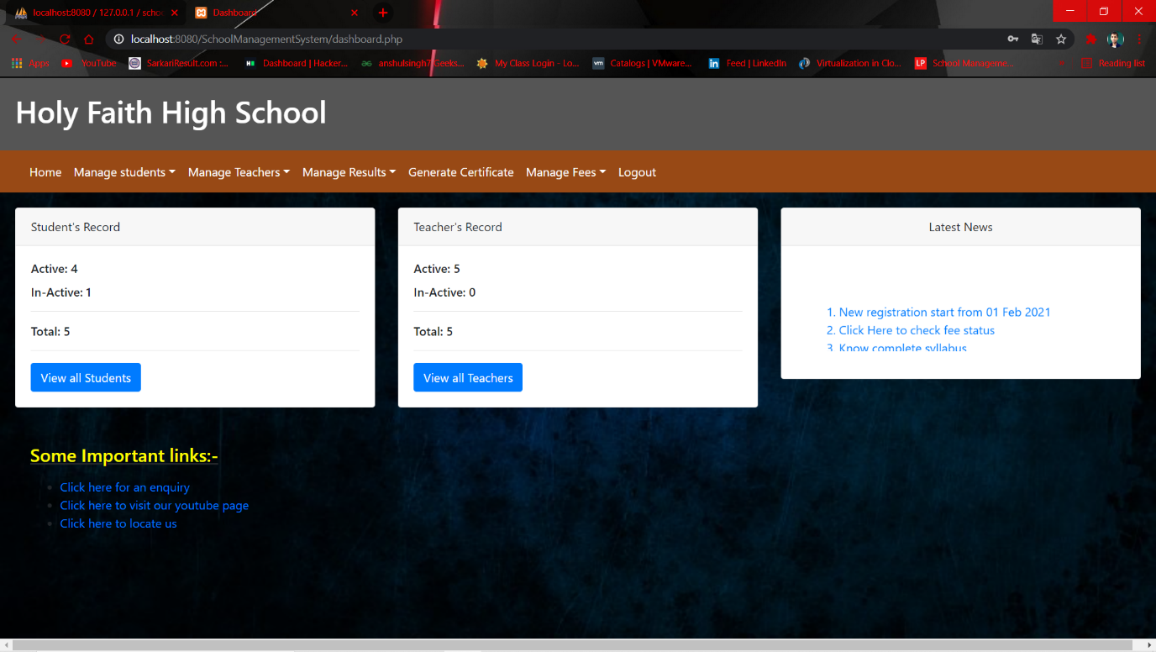

**[4.6] Manage Students**

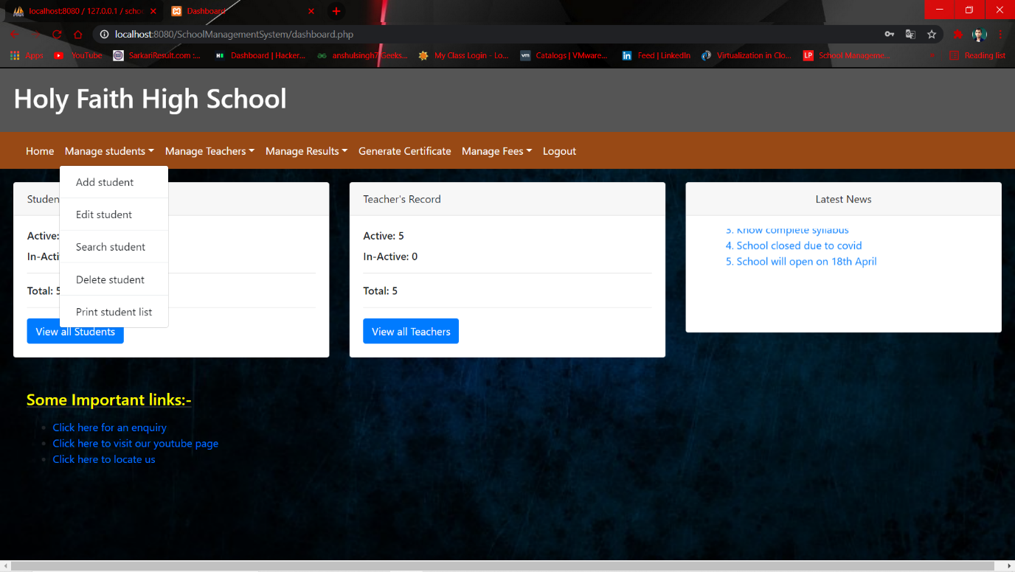

**[4.7] Add Students**

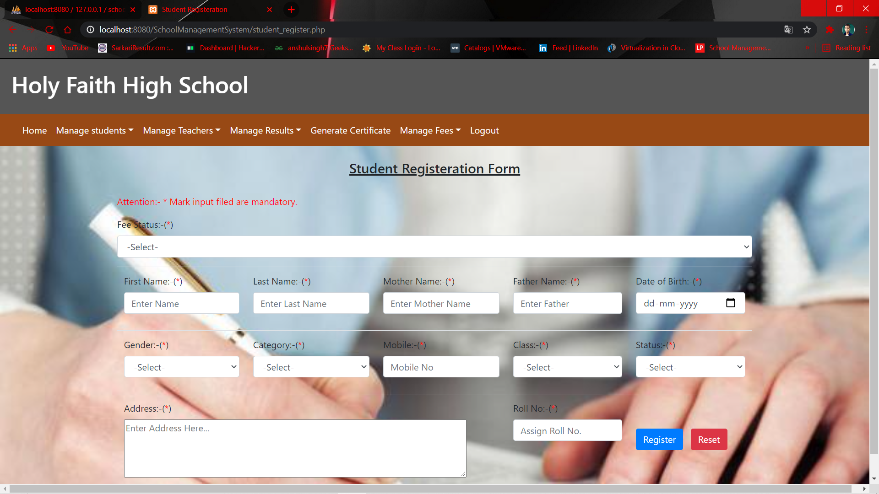

**[4.8] Edit Students**

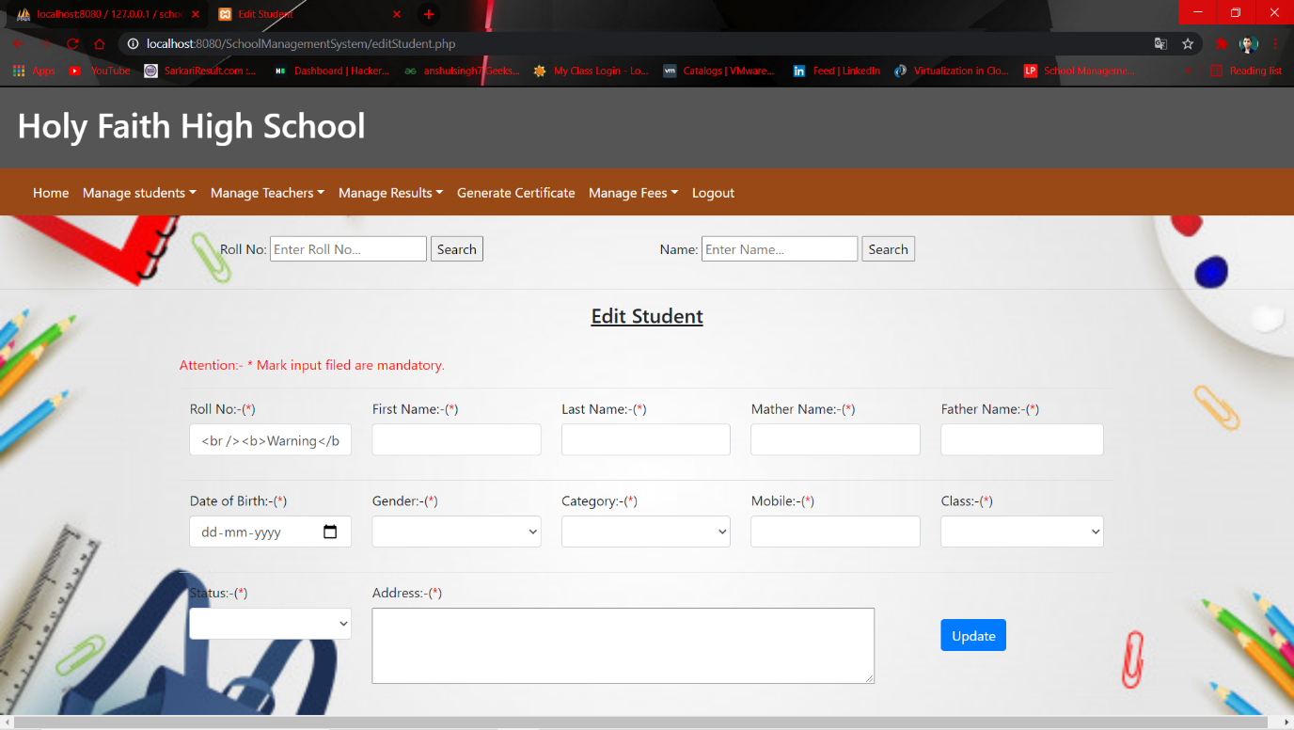

**[4.9] Search Students**

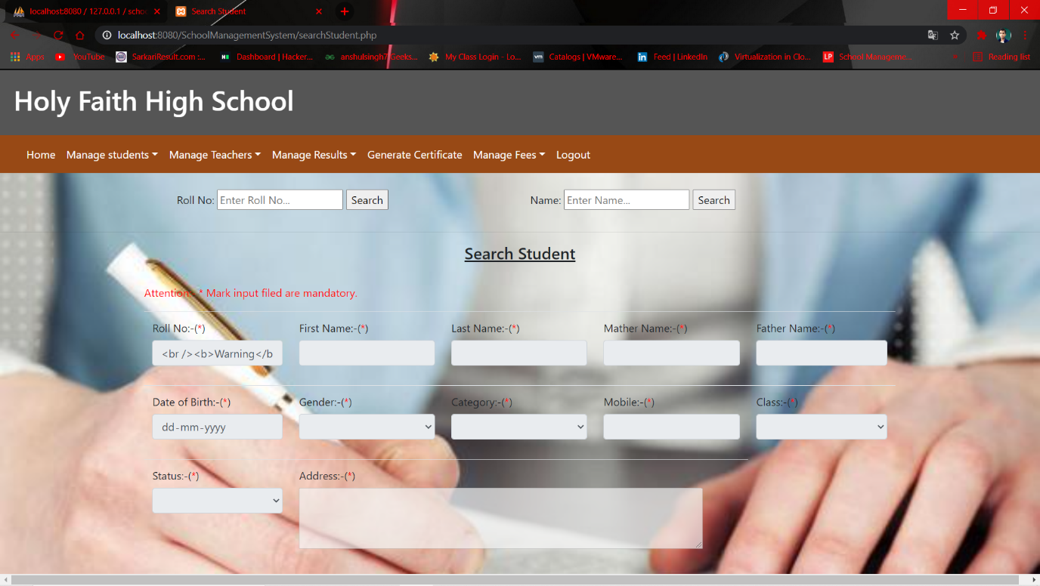

**[4.10] Delete Students**

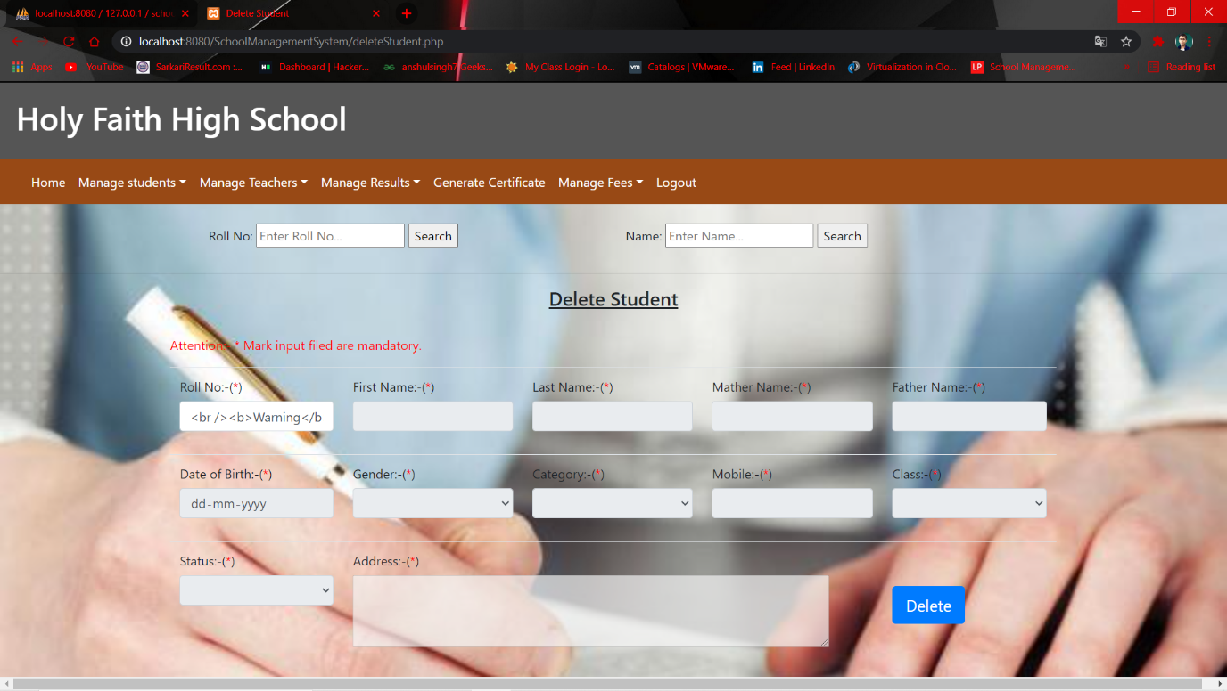

**[4.11] List of All Students**

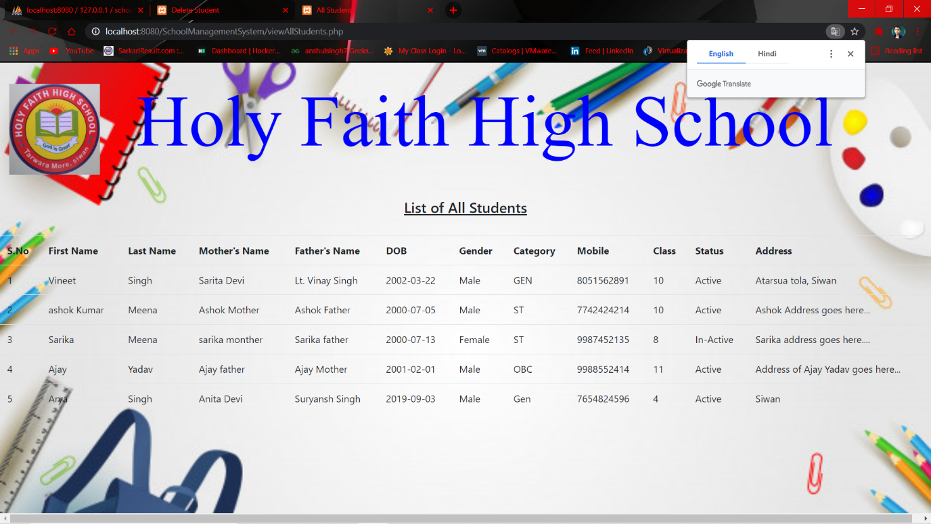

**[4.12] Teacher’s Registration**

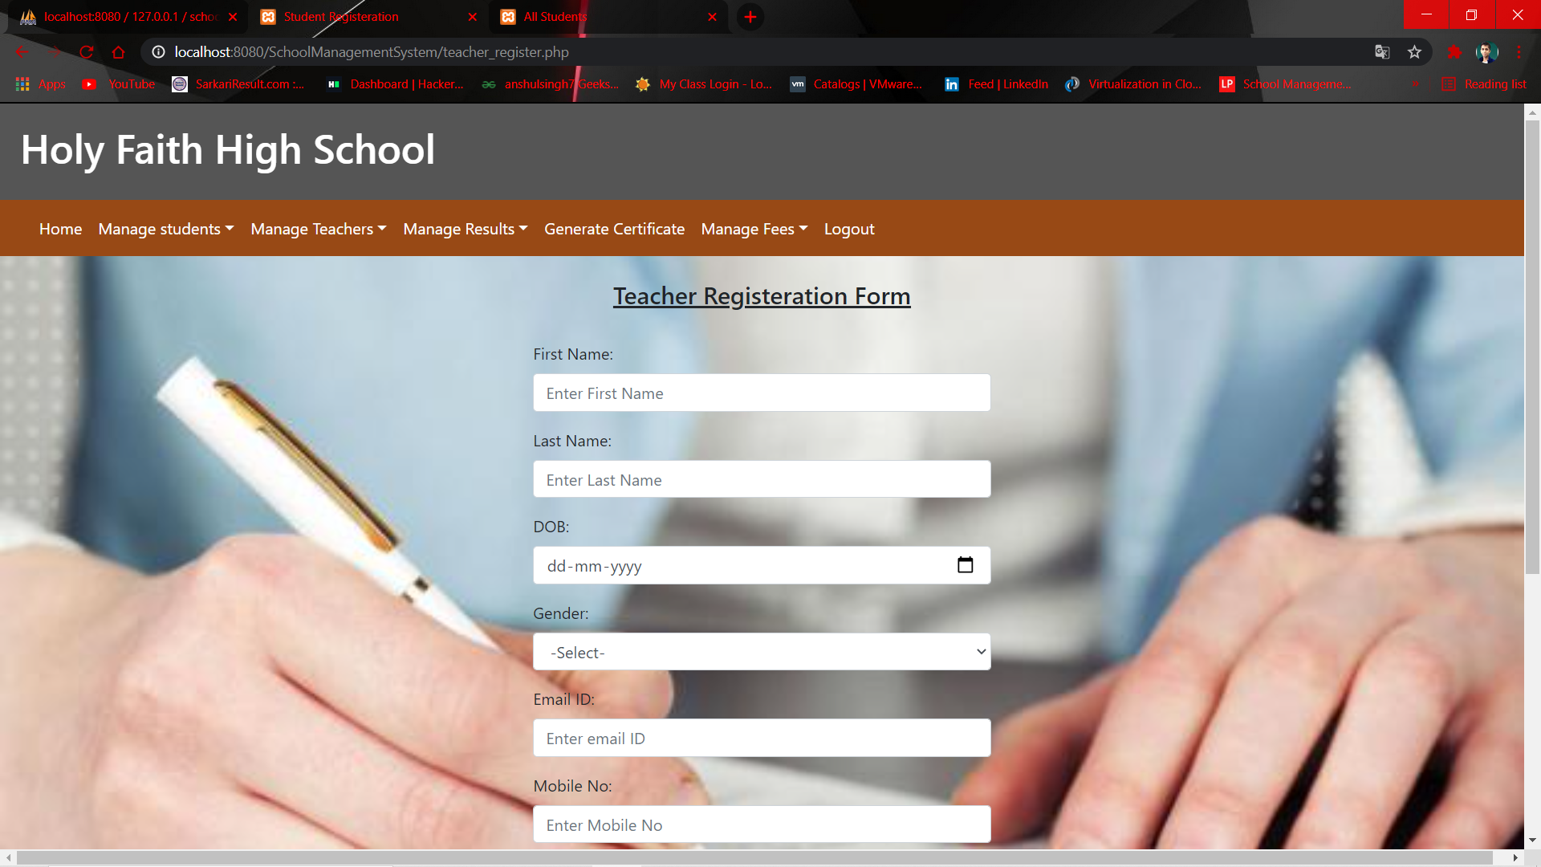

**[4.13] Edit Teacher**

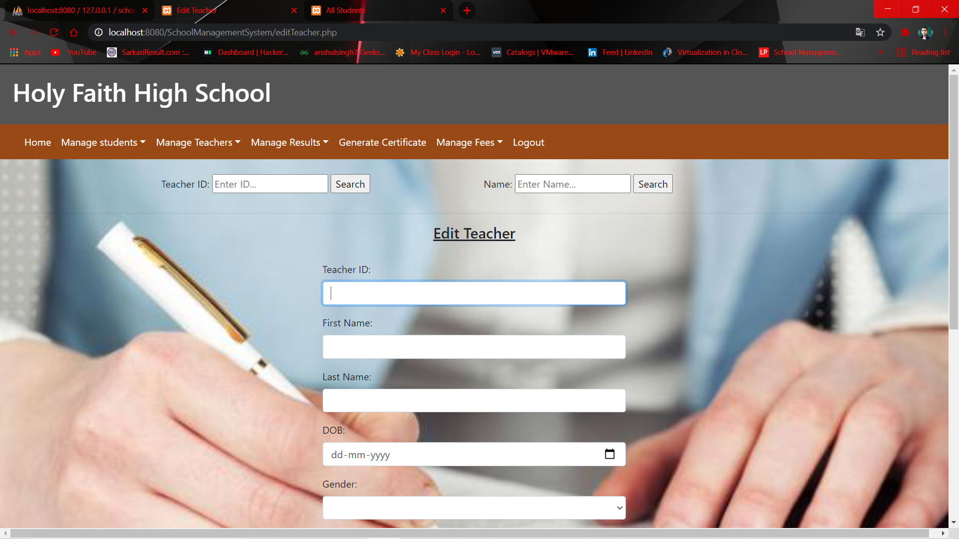

**[4.14] Delete Teacher**

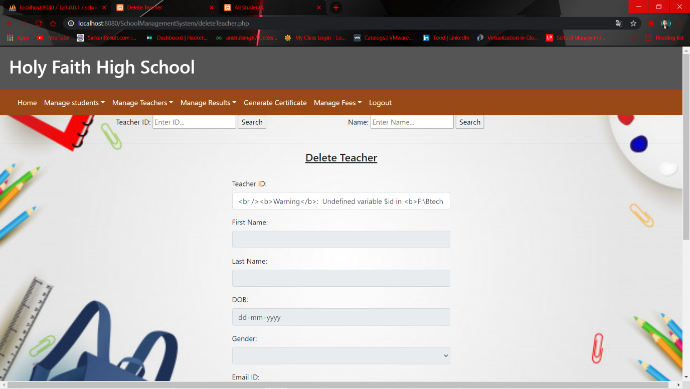

**[4.15] List of all Teacher**

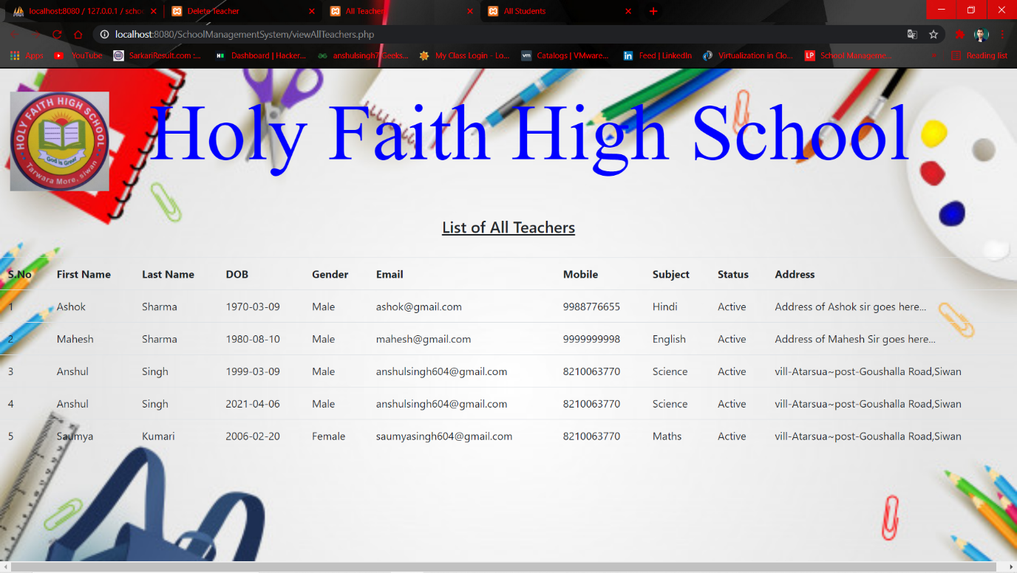

**[4.16] Ceritificate**

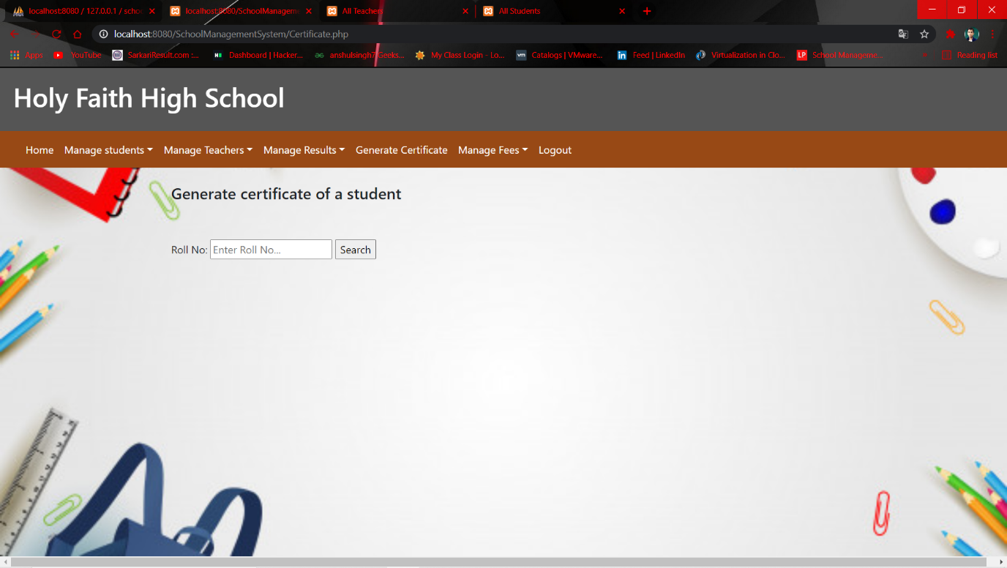

**[4.17] Manage Fee**

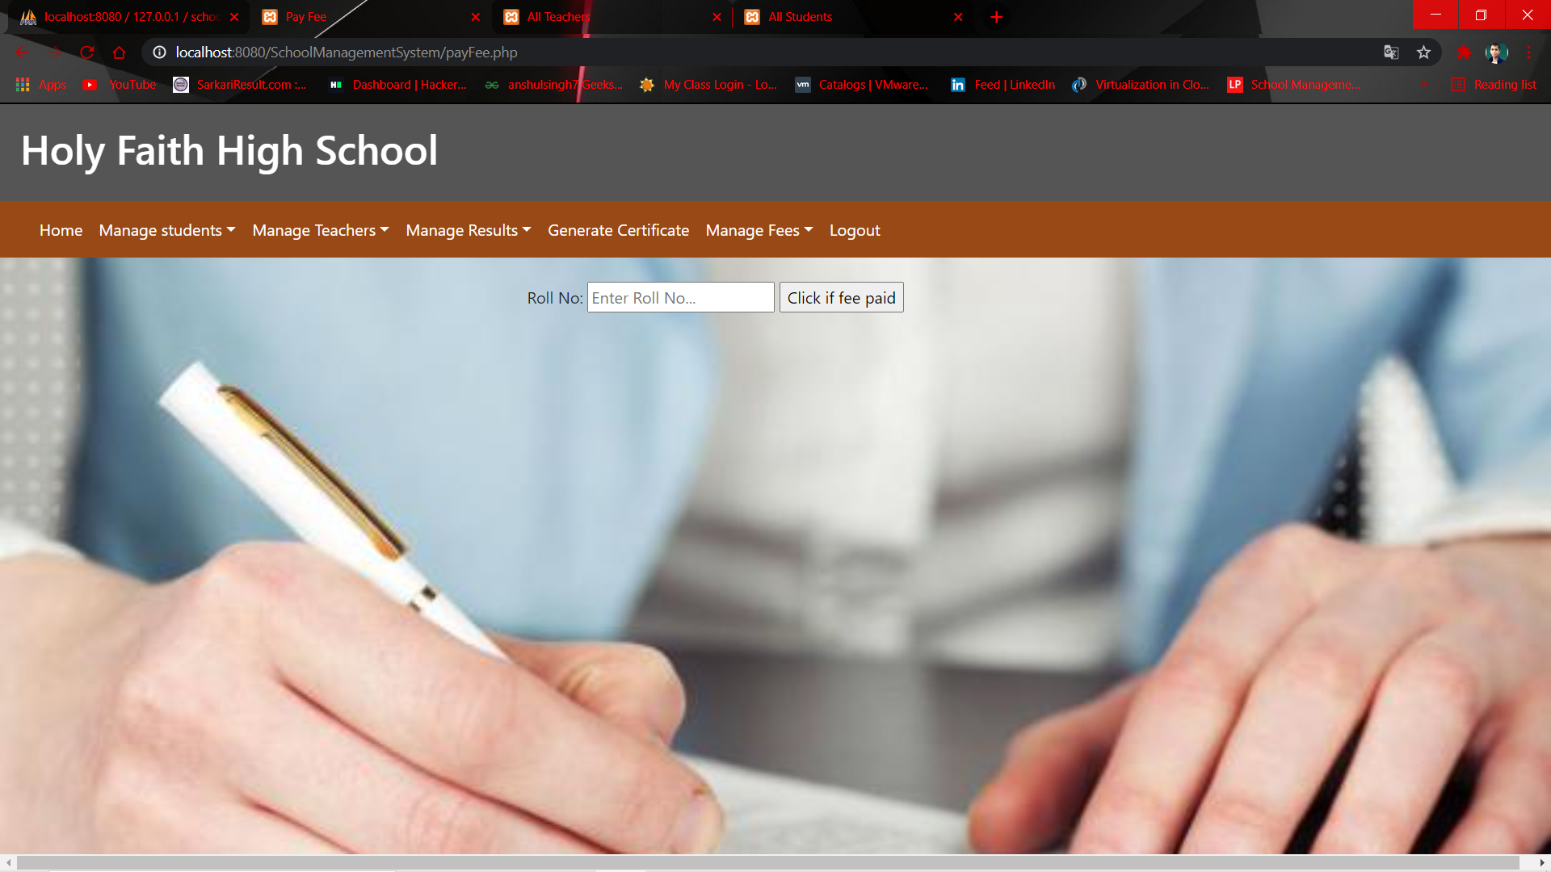

**[4.18] List Of Students who have paid the fee**

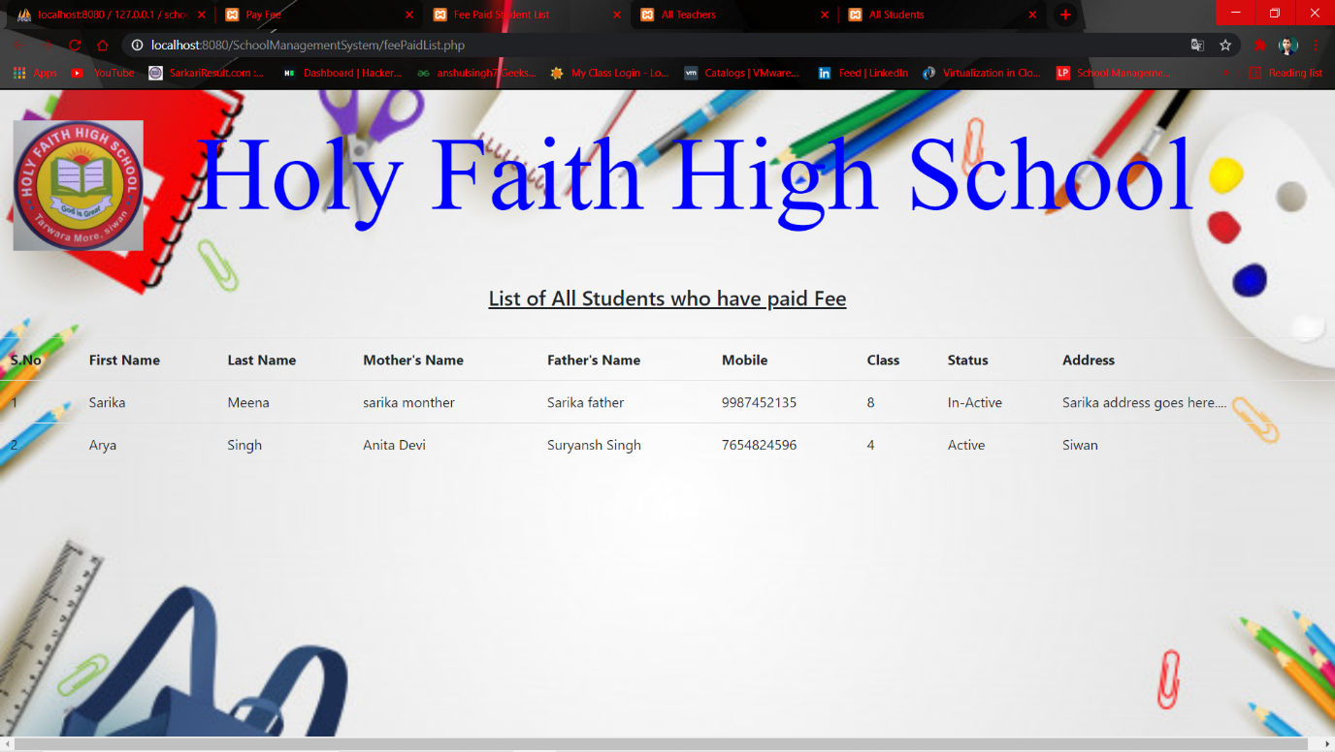

**[4.19] List Of Students who have paid the fee**

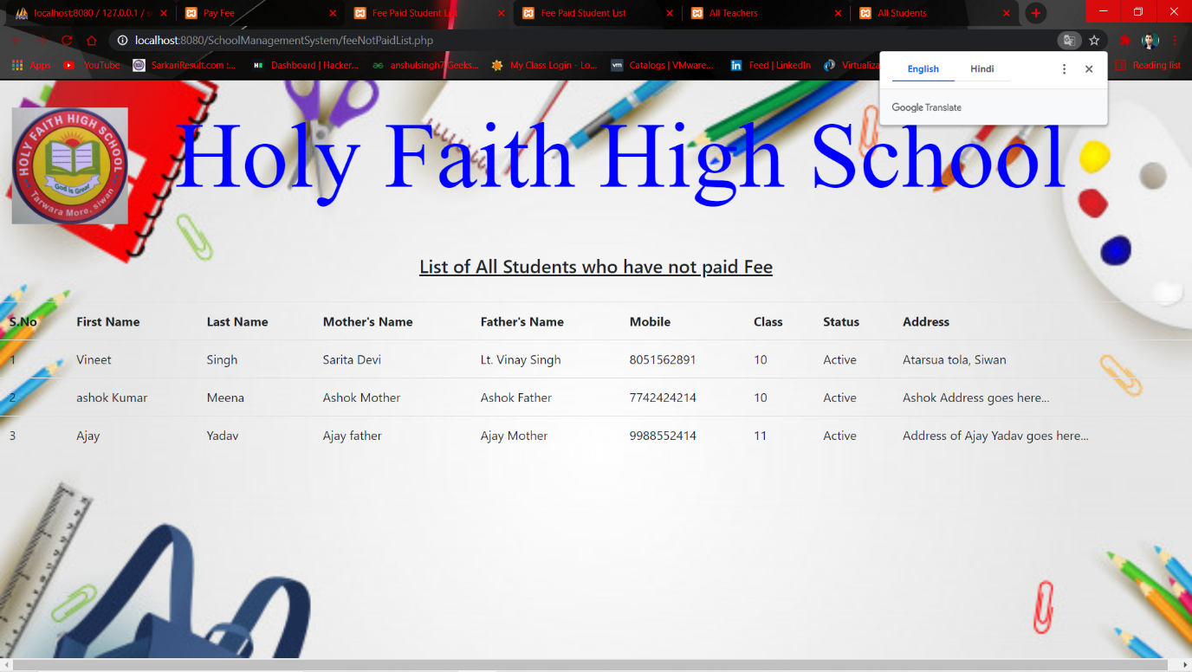

**CHAPTER 5**

**GitHub link and Video Presentation Link**

**[5.1] GitHub Link**

[**https://github.com/anshul-singh604/School_Management_System_PHP**](https://github.com/anshul-singh604/School_Management_System_PHP)

**[5.2] Video Presentation Link**

[**https://www.youtube.com/watch?v=1HRqJKzbl9k**](https://www.youtube.com/watch?v=1HRqJKzbl9k)